CREDIT CARD FRAUD DETECTION USING MACHINE LEARNING
Conclusion, Future Scope and References
Department of Computer Science and Engineering, TKR College of Engineering & Technology
Batch A4 (CSE-A) · Academic year [ACADEMIC YEAR]
Table 1: Project team
S.No. | Student name | Roll number
1 | ARELLI PRAVEEN KUMAR | 23K91A0513
2 | BANOTHU AJAY | 23K91A0529
3 | D CHANDRIKA | 23K91A0557
4 | BAIRAGONI VIJAY | 23K91A0525

Project guide: KOTESHWAR RAO
Chapter and section numbers quoted in the text (for example Chapter 8 or Section 6.2) refer to the full project report, 17.Final Document. Figures and tables in this document are numbered from 1.

1. CONCLUSION

1.1 Summary of the work
This project set out to build and measure a credit card fraud detector based on the quantum-assisted restricted Boltzmann machine of the base paper [1]. We implemented the Gaussian-Bernoulli RBM classifier in NumPy with three trainers, built the preprocessing pipeline the paper describes, wrapped the models in a Flask API with 16 routes and a React interface, and measured everything on a synthetic, balanced file of 39,000 transactions. The quantum trainer is a classical simulation, so the system is quantum-inspired, not quantum.
On the 1,600-row held-out split the ensemble reaches accuracy 94.6%, precision 96.5%, recall 92.5%, F1 94.5% and ROC-AUC 0.986. The annealing and quantum-inspired models reach F1 94.4% and 94.3%. The classical PCD model, at its shipped state, flags nearly every transaction (accuracy 58.8%, recall 100.0%). A single check takes a median 17 ms and a 20-row batch 30 ms.
Beyond the models, the project delivers the pieces that make them usable and checkable: preprocessing and training code that can be rerun, a retraining lab in the interface, bulk screening with an exportable result, analytics over the whole file, an experiment script that regenerates every metric in this report, and a read-only smoke test of the API (20/20 checks pass). A full measurement run, including five seeds and a low-fraud variant, finishes in minutes on one CPU.

1.2 Objectives against outcomes
Table 2: The six objectives and what was achieved
# | Objective | Outcome | Status
1 | Acquire a benchmark dataset and quantify the imbalance | No public benchmark was used. A synthetic file of 39,000 rows (50/50) was generated and a 1%-fraud variant was built to quantify the effect of imbalance | Partly met
2 | Preprocessing: scaling, feature selection, stratified split | One-hot, z-score, correlation filter, importance-based top-18 selection and a stratified 80/20 split | Met (selection before the split)
3 | Balance with SMOTE and compare with random undersampling | Compared in scripts/run_experiments.py on the 1% variant (XGBoost precision is 0.90 with SMOTE and 0.19 with undersampling); the product supports SMOTE and Tomek links in the Lab | Met in the experiment script
4 | Train Logistic Regression, Random Forest and XGBoost | Trained on the same split (F1 96.7%, 96.3%, 96.5%); they are not part of the shipped application, which serves the RBM models | Met as baselines
5 | Evaluate with precision, recall, F1 and ROC-AUC | All four metrics, confusion matrices, a threshold sweep, five seeds and PR-AUC at low fraud | Met
6 | Deploy the best model behind an interface | The interface and API work (20/20 smoke checks pass), but the batch route skips scaling, and the deployed models are not the best models measured | Met with a defect

1.3 Key findings
1. On this synthetic data, ordinary classifiers are better than the RBM. Logistic regression, random forest and XGBoost reach F1 96.7%, 96.3% and 96.5%; the best RBM ensemble reaches 94.5%. The data are easy, so this does not say what would happen on real data.
2. The three trainers differ in reliability more than in best score. SAS is stable (F1 94.4 +/- 0.1 over five seeds), QS is less so (92.9 +/- 1.2), and PCD is unstable (69.2 +/- 23.1).
3. Ranking quality and decision quality are separate. All three models have ROC-AUC near 0.986, but at 0.5 the PCD model is almost useless; the threshold, not the model, is the problem.
4. Imbalance strategy matters more than the model. At 1% fraud, random undersampling drops the precision of all three baselines to between 0.19 and 0.22, while no resampling keeps precision high and recall of 0.66 to 0.81.
5. Silent failure is the main engineering risk. A swallowed exception in the batch route reduced accuracy from 94.8% to 50.2% without any visible error.
6. The base paper's training times (hours) were not reproduced: with a simplified sampler an epoch takes well under a second.
Read together, the findings say that the base paper's recipe works as a classifier on easy data but does not, in this reimplementation, beat the standard tools, is fragile in its classical form, and is only as good as the code around it. None of this contradicts the base paper, which used real data, a far larger scale and quantum hardware. It does show that a student-scale rebuild must be checked against baselines and against its own serving code before any claim is made.

1.4 Comparison with the base paper
The base paper reports F1 of 83 %, 88 % and 84 % for PCD, SAS and QS on real data [1]. Our final-epoch F1 values are 70.9%, 94.4% and 94.3% on synthetic data. The two sets of numbers cannot be compared directly: the data, the epoch count, the hyper-parameter search and the samplers all differ, and on our synthetic data even logistic regression reaches F1 96.7%. What can be said is qualitative. In both studies simulated annealing is the strongest trainer and classical PCD the weakest. Unlike the paper, our quantum-inspired sampler is about as good as the annealing sampler (F1 94.3% against 94.4%), but it is less stable across seeds (92.9 +/- 1.2 against 94.4 +/- 0.1). We did not reproduce the paper's training times, because the samplers here are simplified and run on a CPU, and we make no claim about quantum hardware.

1.5 Practical applications
• A teaching and demonstration tool for how restricted Boltzmann machines classify, how samplers change training, and why accuracy misleads on imbalanced data.
• A starting point for a risk-operations screening screen: single check, bulk file screening, analytics and model views are already wired to an API.
• A template for auditing a model service: the experiment script shows how to compare shipped behaviour with offline behaviour.
For a reader who wants to reuse the work, the most portable parts are the evaluation script and the audit method rather than the models. The script shows how to compare a served model with an offline one, how to vary the imbalance of a stream, and how to report spread over seeds. The interface is a reasonable skeleton for a screening tool once its data source, scaling and security are replaced with production-grade parts.

1.6 Lessons learned
• Evaluate against ordinary baselines early. The RBM looked strong until logistic regression, random forest and XGBoost were trained on the same split and scored higher.
• Never swallow exceptions. A single bare except hid a feature-scaling error for the whole life of the batch route; it was found only because served predictions were compared with offline ones.
• Report final-epoch results. Picking the best epoch on the test split flatters every model, and the interface's dashboard figures show how large the effect is.
• Report the spread, not only the mean. Five seeds turned one apparently usable PCD model into an unstable trainer.
• State what the data are. Synthetic data allow a complete, repeatable study, but every conclusion must carry that caveat.

1.7 Known limitations
We chose to document the defects we found rather than hide them or silently repair them, because the screenshots, the latency figures and the test counts in this report all describe the code as shipped; a repair would change them and would need the measurements to be repeated. That decision keeps the report consistent with the repository and leaves the repair as the first item of future work.
The conclusions rest on synthetic data, one split, one machine and a simulated quantum sampler. The serving defect, the optimistic best-epoch display, the pre-split selection, the lack of authentication and the lack of a regression test are all documented in Chapter 8 and in the limitations document. Until the defect is fixed and the models are checked on real data, SecurePay AI should be treated as a prototype and not as a payment control.
The results behind the key findings are shown below: the shipped models against the simple baselines on the same split, and the stability of the three trainers across five seeds.
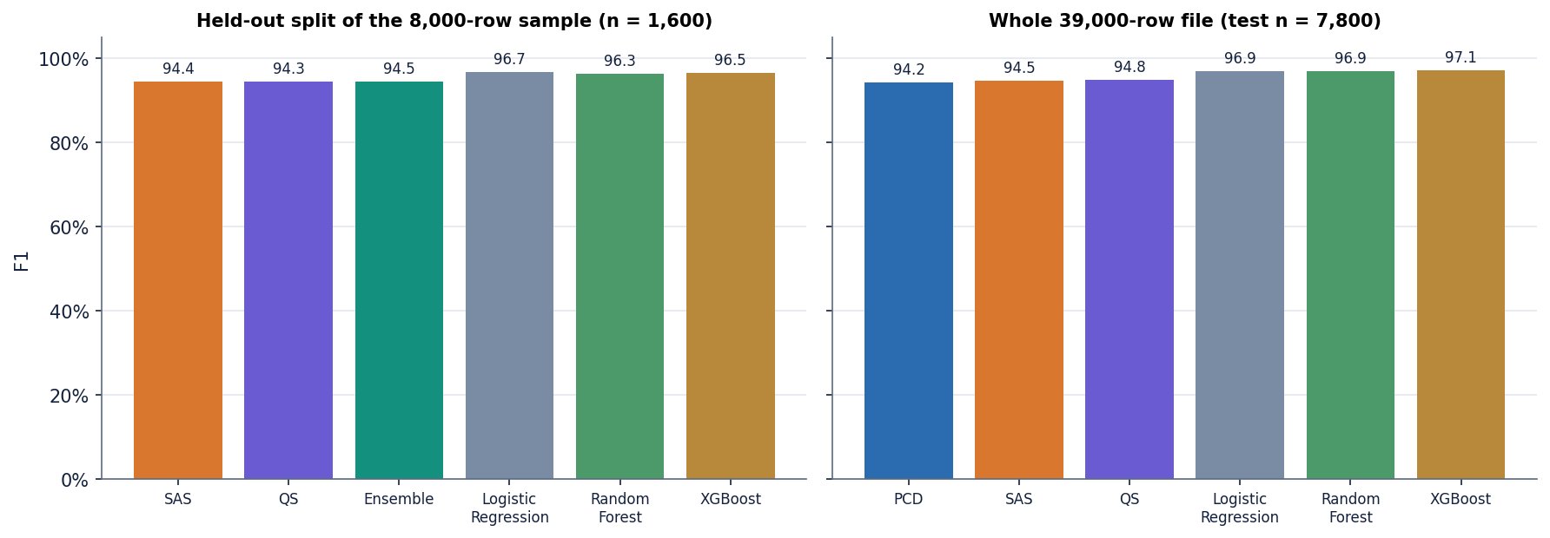
Figure 1: F1 of the three RBM trainers and the ensemble against logistic regression, random forest and XGBoost.
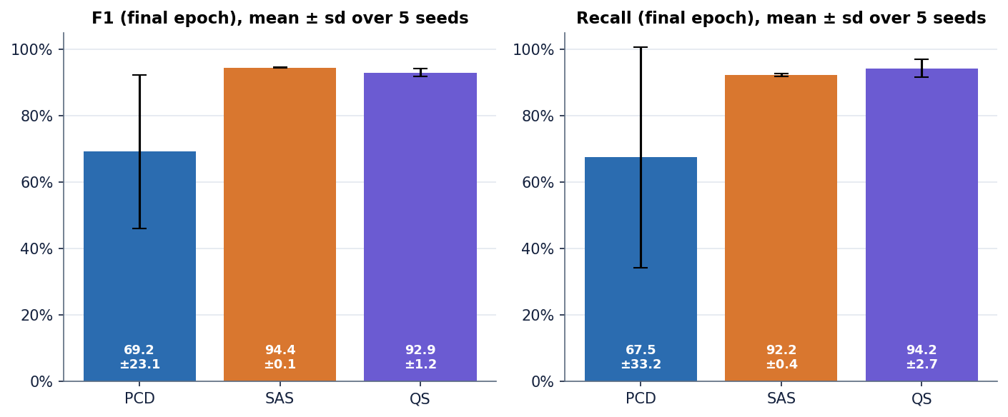
Figure 2: Stability of the three trainers over five seeds: PCD is unstable, SAS is steady.

2. FUTURE SCOPE

2.1 Improvements to the existing system
1. Fix the scaling defect and add a regression test. Transform with all columns of scaler.feature_names_in_ before selecting features, remove the bare except, and compare served probabilities with offline ones in a test that fails if they differ (served accuracy is 50.2% today).
2. Choose the threshold on validation data. Split the data three ways, pick the operating point on the validation part for the cost of a miss against a false alarm, and calibrate the PCD output (for example with isotonic regression).
3. Remove the evaluation leaks. Split first, then scale, resample and select features on the training part only, and report final-epoch or validation-selected figures only.
4. Make the training reproducible and stable. Search the hyper-parameters, average several seeds or use early stopping on a validation split, and report the spread.
Fixing the scaling defect is the single most valuable change, and its effect is already measured offline: with the scaler applied, ensemble accuracy on a fresh batch is 94.8% and false positives fall from 995 to 26. A regression test would send the bundled sample file through the running API and through the offline pipeline and assert that the two probability vectors agree within a tolerance; because it compares by column name, it would also catch a future change of feature order.
The threshold work needs care. In the sweep with steps of 0.05 the ensemble gives F1 94.5% at 0.5 but precision 99.8% with recall only 67.5% at 0.6, and the PCD model flags everything up to 0.5 and nothing from 0.6, so its probabilities are bunched in a very narrow band. A finer search on a validation split, or a monotone calibration such as isotonic regression, is needed before any threshold can be called tuned.
These four items are listed in order of priority. The first removes a known defect, the second and third make the reported figures trustworthy, and the fourth makes them repeatable. Together they would turn the prototype into a system whose numbers can be defended.

2.2 Additional features
• Real-data pilot with a partner's anonymised transactions, with a held-out time period instead of a random split.
• A gradient-boosting champion model beside the RBMs: XGBoost reaches F1 96.5% here and trains in a fraction of a second, so it is the obvious reference for any RBM claim.
• Cost-sensitive decisions and an alert budget, so the three actions reflect money and analyst capacity rather than fixed 0.4 and 0.7 cut-offs.
• Explanations for each decision (feature contributions for the single check), and storage of every prediction for audit.
• A model-monitoring screen with drift statistics and a scheduled retraining job.
Of these, the gradient-boosting champion and the cost-sensitive decision layer matter most. The first gives a fair yardstick for every other model; the second turns a probability into an action in a way a business can reason about, for example by flagging the highest-risk transactions up to a daily review budget of analysts' time.
Explanations deserve a concrete design. For an RBM classifier the free-energy difference between the fraud and legitimate hypotheses can be split into per-feature contributions, so the single-check screen could show which of the 18 inputs pushed the score up. Storing every prediction with its inputs, model version and later label is also the precondition for monitoring and retraining.

2.3 Scalability and deployment
• Replace the Flask development server with a production server behind HTTPS, with authentication and role-based access (analyst and administrator).
• Containerise the API and the web build with Docker, read configuration from the environment and move model files to versioned storage.
• Keep predictions and model versions in a database instead of CSV and pickle files, and make the batch route write per-request files.
• Vectorise scoring for batches (it already is) and load-test with concurrent clients; the measured median of 17 ms per check is for one client.
A realistic target deployment is a containerised API behind a reverse proxy with HTTPS, a managed relational database for predictions, labels and model versions, a scheduled job that retrains and evaluates a candidate model on the latest labelled period, and a promotion step that replaces the serving model only when the candidate beats it on a held-out later period. The present models are small matrix products, so a single process is plausibly enough for a prototype, but throughput under load was not measured and would depend on feature construction and I/O.
One open question in the present results can be tested cheaply. The classical trainer uses batches of 512 rows, so about 13 updates per epoch on 6,400 training rows, while the annealing trainers use batches of 32 over a 3,000-row subsample, about 94 updates per epoch. The instability of PCD (F1 69.2 +/- 23.1 over five seeds) may therefore come from too few updates under a decaying learning rate rather than from the sampler. We have not tested this; a sweep over batch size and learning rate would settle it.
An evaluation protocol for any later study should be fixed in advance: a time-ordered split so that the test period follows the training period, scaling and resampling fitted on the training part only, thresholds chosen on a validation period, and results reported as precision at a fixed alert budget, recall at a fixed false-positive rate and AUPRC, with the spread over several seeds. Such a protocol makes the numbers comparable with the base paper's successors and with the literature on real card data.

2.4 Further research
• Replace the simplified samplers with a faithful path-integral simulated-annealing sampler, and obtain cloud access to a quantum annealer to test whether the effects reported in the base paper appear on real hardware.
• Study the Gaussian-Bernoulli RBM with learned variances and with a binary expansion of the visible units, as the paper's QUBO formulation requires.
• Compare the RBM classifier with a deep belief network, as the paper proposes as future work, and with tabular deep models.
• Evaluate on public benchmarks with realistic imbalance, reporting AUPRC and cost curves as recommended for rare-event problems [16], [34].

2.5 Suggested roadmap
Table 3: Roadmap from prototype to pilot
Phase | Work | Evidence of success
1. Repair | Fix scaling, remove bare exceptions, add the regression test, split before selecting features | Served and offline probabilities agree; test passes in continuous integration
2. Re-measure | Rerun scripts/run_experiments.py with validation-selected thresholds and final-epoch reporting; add the cost-sensitive layer | Updated tables in the report; a stated cost assumption
3. Harden | Authentication, HTTPS, production server, containers, stored predictions | Security checklist passed; deployment from a clean machine
4. Pilot | Score a partner's anonymised, time-ordered transactions; compare RBM, XGBoost and rules at a fixed alert budget | Precision at the budget and recall measured on real data

3. REFERENCES
[1] J. M. C. de Albuquerque Neto, G. C. do Amaral and G. P. Temporao, "Fraud detection in credit card transactions using quantum-assisted restricted Boltzmann machines," IEEE Access, vol. 14, pp. 62923-62932, 2026, doi: 10.1109/ACCESS.2026.3683308.
[2] A. H. M. Aburbeian and H. I. Ashqar, "Credit card fraud detection using enhanced random forest classifier for imbalanced data," arXiv:2303.06514, Mar. 2023.
[3] X. Han and C. Wu, "Validation-stage combinatorial fusion analysis for imbalanced credit-card fraud detection," arXiv:2606.10393, Jun. 2026.
[4] J. Shi, "Credit card fraud detection based on ANN and XGBoost," in Proc. 1st Int. Conf. E-commerce and Artificial Intelligence (ECAI), SciTePress, 2024, pp. 195-199, doi: 10.5220/0013212700004568.
[5] S. Bhattacharyya, S. Jha, K. Tharakunnel and J. C. Westland, "Data mining for credit card fraud: A comparative study," Decision Support Systems, vol. 50, no. 3, pp. 602-613, 2011.
[6] A. Dal Pozzolo, G. Boracchi, O. Caelen, C. Alippi and G. Bontempi, "Credit card fraud detection: A realistic modeling and a novel learning strategy," IEEE Trans. Neural Netw. Learn. Syst., vol. 29, no. 8, pp. 3784-3797, Aug. 2018.
[7] "Research on credit card fraud detection based on PySpark," in Proc. 3rd Int. Conf. Computer Science and Mechatronics, 2025. [Listed in the batch literature survey; authors and pages could not be verified, so it is not cited in the text.]
[8] "Enhancing e-commerce security: A novel approach to credit card fraud detection," 2025. [Listed in the batch literature survey; venue and authors could not be verified, so it is not cited in the text.]
[9] "Credit card fraud detection," Int. J. Research Publication and Reviews, 2025. [Listed in the batch literature survey; authors and volume could not be verified, so it is not cited in the text.]
[10] F. Carcillo, Y.-A. Le Borgne, O. Caelen, Y. Kessaci, F. Oble and G. Bontempi, "Combining unsupervised and supervised learning in credit card fraud detection," Information Sciences, vol. 557, pp. 317-331, 2021.
[11] A. Dal Pozzolo, O. Caelen, R. A. Johnson and G. Bontempi, "Calibrating probability with undersampling for unbalanced classification," in Proc. IEEE Symp. Series on Computational Intelligence (SSCI), 2015, pp. 159-166.
[12] N. V. Chawla, K. W. Bowyer, L. O. Hall and W. P. Kegelmeyer, "SMOTE: Synthetic minority over-sampling technique," J. Artif. Intell. Res., vol. 16, pp. 321-357, Jun. 2002.
[13] I. Tomek, "Two modifications of CNN," IEEE Trans. Syst., Man, Cybern., vol. SMC-6, no. 11, pp. 769-772, Nov. 1976.
[14] H. He and E. A. Garcia, "Learning from imbalanced data," IEEE Trans. Knowl. Data Eng., vol. 21, no. 9, pp. 1263-1284, Sep. 2009.
[15] A. Fernandez, S. Garcia, M. Galar, R. C. Prati, B. Krawczyk and F. Herrera, Learning From Imbalanced Data Sets. Cham, Switzerland: Springer, 2018.
[16] T. Saito and M. Rehmsmeier, "The precision-recall plot is more informative than the ROC plot when evaluating binary classifiers on imbalanced datasets," PLoS ONE, vol. 10, no. 3, Art. no. e0118432, 2015.
[17] T. Fawcett, "An introduction to ROC analysis," Pattern Recognition Letters, vol. 27, no. 8, pp. 861-874, 2006.
[18] D. M. W. Powers, "Evaluation: From precision, recall and F-measure to ROC, informedness, markedness and correlation," arXiv:2010.16061, 2020.
[19] L. Breiman, "Random forests," Machine Learning, vol. 45, no. 1, pp. 5-32, 2001.
[20] T. Chen and C. Guestrin, "XGBoost: A scalable tree boosting system," in Proc. 22nd ACM SIGKDD Int. Conf. Knowledge Discovery and Data Mining, 2016, pp. 785-794.
[21] J. T. Hancock and T. M. Khoshgoftaar, "CatBoost for big data: An interdisciplinary review," J. Big Data, vol. 7, no. 1, p. 94, Dec. 2020.
[22] G. E. Hinton, S. Osindero and Y.-W. Teh, "A fast learning algorithm for deep belief nets," Neural Computation, vol. 18, no. 7, pp. 1527-1554, Jul. 2006.
[23] G. E. Hinton, "Training products of experts by minimizing contrastive divergence," Neural Computation, vol. 14, no. 8, pp. 1771-1800, Aug. 2002.
[24] T. Tieleman, "Training restricted Boltzmann machines using approximations to the likelihood gradient," in Proc. 25th Int. Conf. Machine Learning (ICML), 2008, pp. 1064-1071.
[25] G. E. Hinton, "A practical guide to training restricted Boltzmann machines," in Neural Networks: Tricks of the Trade, 2nd ed. Berlin, Germany: Springer, 2012, pp. 599-619.
[26] A. Fischer and C. Igel, "Training restricted Boltzmann machines: An introduction," Pattern Recognition, vol. 47, no. 1, pp. 25-39, 2014.
[27] H. Larochelle, M. Mandel, R. Pascanu and Y. Bengio, "Learning algorithms for the classification restricted Boltzmann machine," J. Mach. Learn. Res., vol. 13, pp. 643-669, 2012.
[28] R. Liao, S. Kornblith, M. Ren, D. J. Fleet and G. Hinton, "Gaussian-Bernoulli RBMs without tears," arXiv:2210.10318, 2022.
[29] S. Kirkpatrick, C. D. Gelatt Jr. and M. P. Vecchi, "Optimization by simulated annealing," Science, vol. 220, no. 4598, pp. 671-680, 1983.
[30] S. H. Adachi and M. P. Henderson, "Application of quantum annealing to training of deep neural networks," arXiv:1510.06356, 2015.
[31] A. Ajagekar and F. You, "Quantum computing assisted deep learning for fault detection and diagnosis in industrial process systems," Computers & Chemical Engineering, vol. 143, Art. no. 107119, Dec. 2020.
[32] F. Pedregosa et al., "Scikit-learn: Machine learning in Python," J. Mach. Learn. Res., vol. 12, pp. 2825-2830, 2011.
[33] G. Lemaitre, F. Nogueira and C. K. Aridas, "Imbalanced-learn: A Python toolbox to tackle the curse of imbalanced datasets in machine learning," J. Mach. Learn. Res., vol. 18, no. 17, pp. 1-5, 2017.
[34] J. Davis and M. Goadrich, "The relationship between precision-recall and ROC curves," in Proc. 23rd Int. Conf. Machine Learning (ICML), 2006, pp. 233-240.

